A Celebration of Life
For
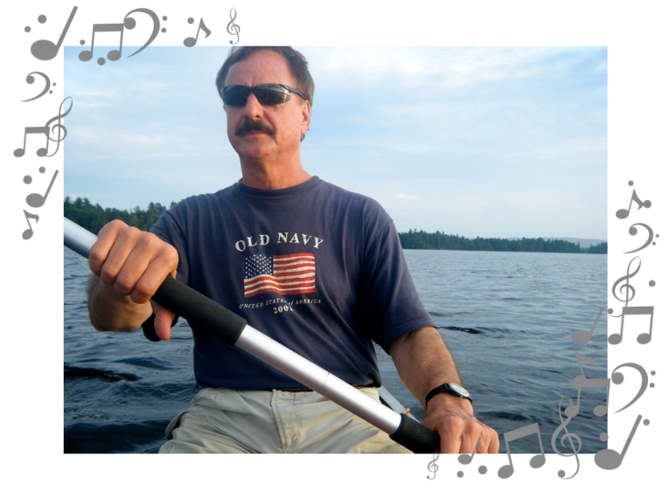

Peter Klarman

July 2, 1952 – March 10, 2022

WELCOME

Please stand as you are able.

GATHERING HYMN I Know That My Redeemer Lives!
ELW #619 + Verses 1-4

THANKSGIVING FOR BAPTISM

When we were baptized in Christ Jesus, we were baptized into his death. We were buried therefore with him by Baptism into death, so that as Christ was raised from the dead by the glory of the Father, we too might live a new life.

For if we have been united with him in a death like his,
we shall certainly be united with him in a resurrection like his.

Eternal God, maker of heaven and earth, who formed us from the dust of the earth, who by your breath gave us life, we glorify you. We glorify you.

Jesus Christ, the resurrection and the life, who suffered death for all humanity, who rose from the grave to open the way to eternal life, we praise you. We praise you.

Holy Spirit, author and giver of life, the comforter of all who sorrow, our sure confidence and everlasting hope, we worship you. We worship you.

To you, O blessed Trinity, be glory and honor, forever and ever. Amen.
OPENING HYMN Eternal Father, Strong to Save ELW #756

GREETING

Blessed be the God and Father of our Lord Jesus Christ,
the source of all mercy and the God of all consolation.
He comforts us in our sorrows so that we can comfort others in their sorrows with the consolation we ourselves have received from God.
Thanks be to God.

PRAYER OF THE DAY

Compassionate God, give courage and faith to all who mourn, that we may have strength to meet the days ahead with steadfastness and patience; not as those who are without hope, but in thankful remembrance of your great goodness, and in the joyful expectation of eternal life in your presence, with those we love; through Jesus Christ, our Savior and Lord.
Amen.

Please be seated.

READING Psalm 96, NRSV

¹O sing to the Lord a new song;
sing to the Lord, all the earth.
² Sing to the Lord, bless his name;
tell of his salvation from day to day.
³ Declare his glory among the nations,
his marvelous works among all the peoples.
⁴ For great is the Lord, and greatly to be praised;
he is to be revered above all gods.
⁵ For all the gods of the peoples are idols,
but the Lord made the heavens.
⁶ Honor and majesty are before him;
strength and beauty are in his sanctuary.
⁷ Ascribe to the Lord, O families of the
peoples,
ascribe to the Lord glory and strength.
⁸ Ascribe to the Lord the glory due his name;
bring an offering, and come into his courts.
⁹ Worship the Lord in holy splendor;
tremble before him, all the earth.
¹⁰ Say among the nations, “The Lord is king!
The world is firmly established; it shall never be moved.
He will judge the peoples with equity.”
¹¹ Let the heavens be glad, and let the earth rejoice;
let the sea roar, and all that fills it;
¹² let the field exult, and everything in it.
Then shall all the trees of the forest sing for joy
¹³ before the Lord; for he is coming,
for he is coming to judge the earth.
He will judge the world with righteousness,
and the peoples with his truth.

SOLO “Wayfaring Stranger”
Ashley Lemmo, Soloist


REMEMBRANCE The Rev. Analyse Triolo
with the Family and Friends
of Peter Klarman
Please stand as you are able.

HYMN OF THE DAY Beautiful Savior
ELW #838 + Verses 1, 2, & 4

PRAYERS

Most gracious God, Our loved one Peter was given the promise of eternal life in baptism. Give him communion with your saints forever.
God in your mercy, receive our prayer.

Merciful Parent, your Son wept at the death of Lazarus; look with compassion on Peter’s dearest loved ones, now experiencing sorrow and pain at his death. Grant the tender healing of your love.
God in your mercy, receive our prayer.

Living God, source of compassion, our hearts are filled with grief at the death of Peter. Draw us near to you in faith and to one another in love.
God in your mercy, receive our prayer.

God of salvation, we remember with thanksgiving all who have died in the hope of the resurrection. Surround us with the light of your presence.
God in your mercy, receive our prayer.

God of peace, grant to us who are still in our pilgrimage, who walk as yet by faith, that, where this world groans in grief and pain, your Holy Spirit may lead us to bear witness to your light and life.
God in your mercy, receive our prayer.

All these things and whatever else you see that we need, grant us, O God, for the sake of Christ who died and rose again, and now lives and reigns with you and the Holy Spirit, one God, forever and ever. Amen.

THE LORD’S PRAYER

Our Father, who art in heaven, hallowed be thy name,
thy kingdom come, thy will be done, on earth as it is in heaven. Give us this day our daily bread; and forgive us our trespasses, as we forgive those who trespass against us; and lead us not into temptation, but deliver us from evil. For thine is the kingdom, and the power, and the glory, forever and ever. Amen.

COMMENDATION

In sure and certain hope of the resurrection to eternal life through our Lord Jesus Christ, we commend to you O God, our loved one Peter, and we commit his body to its resting place, earth to earth, ashes to ashes, dust to dust. The Lord bless him and keep him. The Lord’s face shine on him with grace and mercy. The Lord look upon him with favor and ☩ give him peace.
Amen.
Most merciful God, whose wisdom is beyond our understanding, deal graciously with all those gathered here in their grief. Surround us with your love that we may not be overwhelmed by our loss, but have confidence in your goodness, and strength to meet the days to come; through Jesus Christ, our Savior and Lord.
Amen.
Please be seated.

BLESSING “Blessing for the Broken Hearted” by Jan Richardson
CLOSING HYMN Thine is the Glory
ELW #376
DISMISSAL Psalm 100, NRSV
¹Make a joyful noise to the LORD, all the earth.
²Worship the LORD with gladness;
come into his presence with singing.
³Know that the LORD is God.
It is he that made us, and we are his;
we are his people, and the sheep of his pasture.
⁴Enter his gates with thanksgiving,
and his courts with praise.
Give thanks to him, bless his name.
⁵For the LORD is good;
his steadfast love endures forever,
and his faithfulness to all generations.
Go in peace, you are the body of Christ. Thanks be to God.
In lieu of flowers donations can be made to the Holy Trinity Lutheran Church Music Fund or the National Spine Health Foundation at www.spinehealth.org.


Holy Trinity
Evangelical
Lutheran Church

246-55 87th Avenue

Bellerose, NY 11426
Phone: 718-347-0278

Web: holytrinitybellerose.org

E-mail: office@holytrinitybellerose.org

The Rev. Analyse Triolo Pastor
Holy Trinity Lutheran Church
Bellerose, NY

