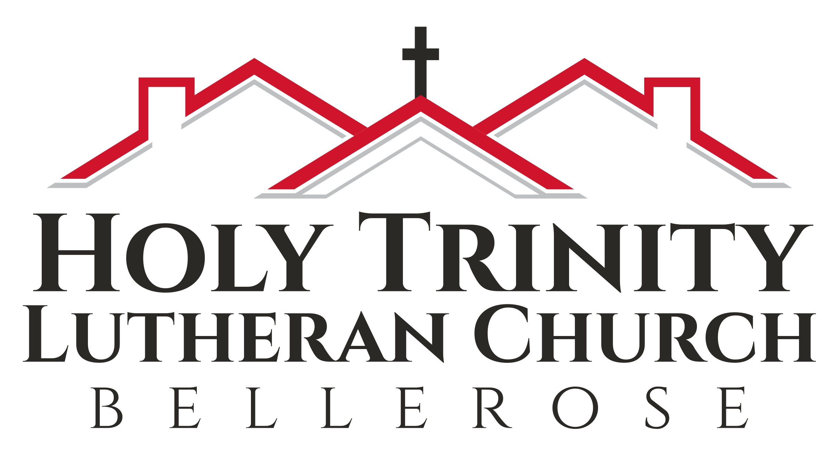

Maundy Thursday Worship

April 14, 2022 + 8 pm

Introduction to the Day

Agape (Ah-GAH-pay) is one of three Greek words that are used to speak of love. Philia is brotherly or friendly love, (Philadelphia, city of brotherly love) Eros, is erotic or sexual love and Agape, is love of God for us, a self-giving love given freely. Agape is the most common word for love in the New Testament.
Our Holy Communion, or Lord’s Supper, is a celebration of God’s agape love for us. The love (agape) feast is a meal of Christian fellowship that mirrors the meals Jesus shared with his disciples and others throughout his ministry. The believers would gather on the Lord’s Day. Fellowship and community were celebrated around the theme of a meal. They would take some bread and wine and set it aside to fulfill Jesus’ command to “do this in remembrance of me”. Each time we gather on the Lord’s Day, we remember that meal that Jesus shared with his disciples “on the night he was betrayed”.

Greeting

1st Reading Exodus 12:1-4, 11-14
The first reading is from Exodus beginning at the 12th chapter.

The Lord said to Moses and Aaron in the land of Egypt: This month shall mark for you the beginning of months; it shall be the first month of the year for you. Tell the whole congregation of Israel that on the tenth of this month they are to take a lamb for each family, a lamb for each household. If a household is too small for a whole lamb, it shall join its closest neighbor in obtaining one; the lamb shall be divided in proportion to the number of people who eat of it. This is how you shall eat it: your loins girded, your sandals on your feet, and your staff in your hand; and you shall eat it hurriedly. It is the passover of the
Lord. For I will pass through the land of Egypt that night, and I will strike down every firstborn in the land of Egypt, both human beings and animals; on all the gods of Egypt I will execute judgments: I am the Lord. The blood shall be a sign for you on the houses where you live: when I see the blood, I will pass over you, and no plague shall destroy you when I strike the land of Egypt.
This day shall be a day of remembrance for you. You shall celebrate it as a festival to the Lord; throughout your generations you shall observe it as a perpetual ordinance.
Word of God, word of life.
Thanks be to God.

2nd Reading Psalm 116:1-2, 12-19
We will now read responsively from Psalm 116.

¹I love the Lord, who has heard my voice,
and listened to my supplication,
²for the Lord has given ear to me
whenever I called.
¹²How shall I repay the Lord
for all the good things God has done for me?
¹³I will lift the cup of salvation
and call on the name of the Lord.
¹⁴I will fulfill my vows to the Lord
in the presence of all God’s people.
¹⁵Precious in your sight, O Lord,
is the death of your servants.
¹⁶O Lord, truly I am your servant;
I am your servant, the child of your handmaid; you have freed me from my bonds.
¹⁷I will offer you the sacrifice of thanksgiving
and call upon the name of the Lord.
¹⁸I will fulfill my vows to the Lord
in the presence of all God’s people,
¹⁹in the courts of the Lord’s house,
in the midst of you, O Jerusalem.

~Please stand as you are able~
Hymn Jesu, Jesu ELW 708 vs. 1-3

Refrain: Jesu, Jesu, fill us with your love, show us how to serve the neighbors we have from you.
Kneels at the feet of his friends, silently washes their feet, master who acts as a slave to them. Refrain
Neighbors are wealthy and poor, varied in color and race, neighbors are nearby and far away. Refrain
These are the ones we should serve, these are the ones we should love; all these are neighbors to us and you. Refrain
Prayer of the Day
Let us pray. Holy God, source of all love, on the night of his betrayal, Jesus gave us a new commandment, to love one another as he loves us. Write this commandment in our hearts, and give us the will to serve others as he was the servant of all, your Son, Jesus Christ, our Savior and Lord, who lives and reigns with you and the Holy Spirit, one God, now and forever. Amen.

Gospel Reading John 13:1-27, 33-35
The Holy Gospel according to John beginning at the 13th chapter.

It was just before the Passover Festival. Jesus knew that the hour had come for him to leave this world and go to the Father. Having loved his own who were in the world, he loved them to the end. ² The evening meal was in progress, and the devil had already prompted Judas, the son of Simon Iscariot, to betray Jesus. ³ Jesus knew that the Father had put all things under his power, and that he had come from God and was returning to God; ⁴ so he got up from the meal, took off his outer clothing, and wrapped a towel around his waist. ⁵ After that, he poured water into a basin and began to wash his disciples’ feet, drying them with the towel that was wrapped around him. ⁶ He came to Simon Peter, who said to him, “Lord, are you going to wash my feet?”
⁷ Jesus replied, “You do not realize now what I am doing, but later you will understand.”
⁸ “No,” said Peter, “you shall never wash my feet.” Jesus answered, “Unless I wash you, you have no part with me.” ⁹ “Then, Lord,” Simon Peter replied, “not just my feet but my hands and my head as well!” ¹⁰ Jesus answered, “Those who have had a bath need only to wash their feet; their whole body is clean. And you are clean, though not every one of you.” ¹¹ For he knew who was going to betray him, and that was why he said not every one was clean. ¹² When he had finished washing their feet, he put on his clothes and returned to his place. “Do you understand what I have done for you?” he asked them. ¹³ “You call me ‘Teacher’ and ‘Lord,’ and rightly so, for that is what I am. ¹⁴ Now that I, your Lord and Teacher, have washed your feet, you also should wash one another’s feet. ¹⁵ I have set you an example that you should do as I have done for you. ¹⁶ Very truly I tell you, no servant is greater than his master, nor is a messenger greater than the one who sent him. ¹⁷ Now that you know these things, you will be blessed if you do them. ¹⁸ “I am not referring to all of you; I know those I have chosen. But this is to fulfill this passage of Scripture: ‘He who shared my bread has turned against me.’¹⁹ “I am telling you now before it happens, so that when it does happen you will believe that I am who I am. ²⁰ Very truly I tell you, whoever accepts anyone I send accepts me; and whoever accepts me accepts the one who sent me.” ²¹ After he had said this, Jesus was troubled in spirit and testified, “Very truly I tell you, one of you is going to betray me.” ²² His disciples stared at one another, at a loss to know which of them he meant. ²³ One of them, the disciple whom Jesus loved, was reclining next to him. ²⁴ Simon Peter motioned to this disciple and said, “Ask him which one he means.”²⁵ Leaning back against Jesus, he asked him, “Lord, who is it?”
²⁶ Jesus answered, “It is the one to whom I will give this piece of bread when I have dipped it in the dish.” Then, dipping the piece of bread, he gave it to Judas, the son of Simon Iscariot. ²⁷ As soon as Judas took the bread, Satan entered into him. ³³ “My children, I will be with you only a little longer. You will look for me, and just as I told the Jews, so I tell you now: Where I am going, you cannot come.
³⁴ “A new command I give you: Love one another. As I have loved you, so you must love one another. ³⁵ By this everyone will know that you are my disciples, if you love one another.”

Prayers of the People

Merciful God… Receive our prayer.

Peace
We share God’s peace with one another

~Please be seated~
4th Reading 1 Corinthians 11:27-33
The fourth reading is from 1 Corinthians beginning at the 11th chapter.

²³For I received from the Lord what I also handed on to you, that the Lord Jesus on the night when he was betrayed took a loaf of bread, ²⁴and when he had given thanks, he broke it and said, “This is my body that is for you. Do this in remembrance of me.” ²⁵In the same way he took the cup also, after supper, saying, “This cup is the new covenant in my blood. Do this, as often as you drink it, in remembrance of me.” ²⁶For as often as you eat this bread and drink the cup, you proclaim the Lord’s death until he comes.
Word of God, word of life.
Thanks be to God.

Confession and Forgiveness
Friends in Christ, in this Lenten season we have heard our Lord's call to struggle against sin and death,—all that keeps us from loving God and each other. This is the struggle to which we were called at baptism. Within the community of the church, God never wearies of forgiving sin and giving the peace of reconciliation.
On this night let us confess our sin against God and our neighbor, and enter the celebration of the great Three Days reconciled with God and with one another.
Silence is kept for reflection.
Most merciful God,
we confess that we are captive to sin and cannot free ourselves. We have sinned against you in thought, word, and deed, by what we have done and by what we have left undone. We have not loved you with our whole heart; we have not loved our neighbors as ourselves. For the sake of your Son, Jesus Christ, have mercy on us. Forgive us, renew us, and lead us, so that we may delight in your will and walk in your ways, to the glory of your holy name. Amen.
In the mercy of almighty God, Jesus Christ was given to die for us, and for his sake God forgives us all our sins. As a called and ordained minister of the church of Christ and by his authority, I therefore declare to you the entire forgiveness of all your sins, in the name of the Father, and of the + Son, and of the Holy Spirit. Amen.
The Lord’s Supper
In the bread and cup of the Lord's Supper, we experience intimate fellowship with Christ and with one another, because it involves his body given for us and the new covenant in his blood. Participation in this meal is a living proclamation of Christ's death until he comes again.

~Please stand as you are able~
The Lord be with you.
And also with you.
Lift up our hearts
We lift them to the Lord.
Let us give God thanks and praise.
It is right to give God thanks and praise.

It is indeed right, our duty and our joy that we should at all times and in all places give thanks and praise to you, O Lord, holy Father, through Christ our Lord; who on the tree of the cross gave salvation to all, that where death began, there life might be restored, and that he, who by a tree once overcame, might by a tree be overcome. And so, with the Church on earth and the hosts of heaven, we praise your name and join their unending hymn:
Holy, holy, holy, Lord. God of power and might. Heaven and earth are full of your glory. Hosanna in the highest. Blesses is he who comes in the name of the Lord. Hosanna in the highest.

The Lord’s Prayer
Our Father, who art in heaven, hallowed be thy name, thy kingdom come, thy will be done, on earth as it is in heaven. Give us this day our daily bread; and forgive us our trespasses, as we forgive those who trespass against us; and lead us not into temptation, but deliver us from evil.
For thine is the kingdom, and the power, and the glory, forever and ever. Amen.

5th Reading 1 Corinthians 11:23-24
For I received from the Lord what I also handed on to you, that the Lord Jesus on the night when he was betrayed took a loaf of bread, and when he had given thanks, he broke it and said, ‘This is my body that is for you. Do this in remembrance of me.’
As you give the bread, say: The body of Christ, given for you.
HYMN Sanctuary GtG 701

Lord prepare me to be a sanctuary,
Pure and Holy, Tried and True,
With thanksgiving,
I’ll be a living sanctuary for you. Repeat

6th Reading 1 Corinthians 11:25-26
In the same way he took the cup also, after supper, saying, ‘This cup is the new covenant in my blood. Do this, as often as you drink it, in remembrance of me.’ For as often as you eat this bread and drink the cup, you proclaim the Lord’s death until he comes.
As you give the wine, say:
The blood of Christ, shed for you.

Holy Communion
All are welcome to the Lord’s Table. When you come to the front please wear your mask while receiving the elements. We ask that you wait until you are back at your seat to partake. Please tell the ushers if you need the bread and wine brought to you. If you are not yet receiving communion, or do not wish to receive today, please come forward and cross your arms over your chest to receive a blessing. Follow the usher’s directions.

Blessing
The body and blood of your Lord Jesus Christ, nourish you and sustain you in his grace.

Prayer after Communion
Let us Pray, Lord Jesus, in a wonderful sacrament you strengthen us with the saving power of your suffering, death, and resurrection. May this sacrament of your body and blood so work in us that the fruits of your redemption will show forth in the way we live, for you live and reign with the Father and the Holy Spirit, one God, now and forever. Amen.

~Please be seated~
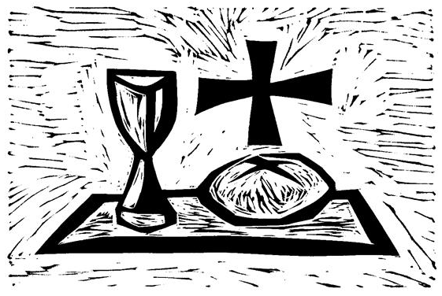
Stripping of the Altar
We move to the sanctuary for the stripping of the altar in preparation for Good Friday. After the altar has been cleared, the service is concluded. You may remain for prayer or meditation and then depart in silence.
No benediction or dismissal is said until Easter morning, when our three day observance of the saving works of Jesus on the cross climax with joy in songs of praise!
No offering is collected during this service; offering plates have been placed by the doors for your gifts.

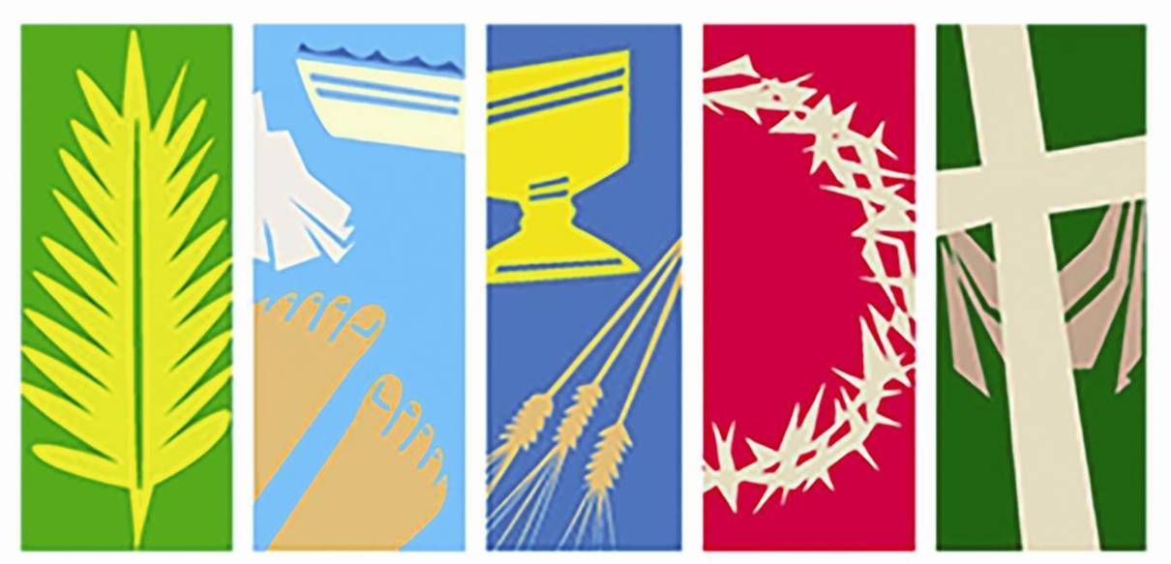
Holy Week & Easter Schedule

Good Friday
- April 15 + 8:00pm + Worship Space Tenebrae Service with Bidding Prayers.
Resurrection of Our Lord
- April 17 + 10:00am
Liturgy with Holy Communion,
Coffee Hour at 11:00am

No Sunday School on Easter Sunday.
Children worship with their families.

Holy Trinity Evangelical
Lutheran Church

24655 87th Avenue
Bellerose, NY 11426
718-347-0278
holytrinintybellerose.org
office@holytrinitybellerose.org

Assisting in Worship
Pastor: The Rev. Analyse Triolo
Musician: Jean Klarman
Reader: Ken Henyan
Communion Assistant: Denice Watkins
Video Grace Gallaher

