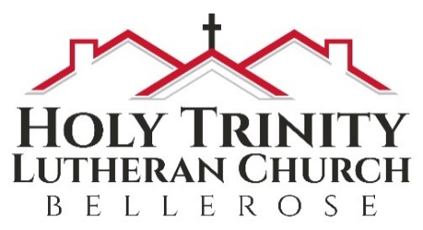
Holy Trinity Evangelical Lutheran Church

January 22, 2023
10:00 am

Third Sunday after Epiphany

We are blessed that you have joined us to celebrate the birth of Our Savior.

Notes on worship:
BOLD type = people of God = You
Regular type = leader
Italic type = directions or explanations

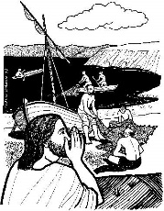
PRELUDE

Introduction to the Day
Jesus begins his public ministry by calling fishers to leave their nets and follow him. In Jesus the kingdom of God has come near. We who have walked in darkness have seen a great light. We see this light most profoundly in the cross—as God suffers with us and all who are oppressed by sickness, sin, or evil. Light dawns for us as we gather around the word, the font, and the holy table. We are then sent to share the good news that others may be “caught” in the net of God’s grace and mercy

WELCOME
We are delighted that you are here with us in person and online! If you have a church home at present but are prevented from joining with them because of the Coronavirus, we say
Welcome to you for the present. If you do not have a church home, please consider Holy Trinity to be yours! If Pastor Analyse or the Prayer Team can provide any care for you at presence please reach out in person or at pastoranalyse@holytrinitybellerose.org or the church office at office@holytrinitybellerose.org.

~Please stand as you are able~

Confession and Forgiveness
Blessed be the holy Trinity, ☩ one God,
who makes all things new,
whose mercy endures forever.
Amen.
Trusting in God’s mercy, let us confess our sin.
Silence is kept for reflection.
Holy One, source of our renewal,
we confess that we are wrapped up in sin,
and cannot free ourselves.
We have not practiced your righteousness.
Our hearts have turned away from you.
For the sake of the world you so love,
forgive us,
that we may be reconciled to one another
for the glory of your holy name.
Amen.
Thus says our God:
“The former things have come to pass
and new things I now declare.”
God’s mercy makes us new.
We are forgiven in the name of ☩ Christ our Savior.
Amen.

GATHERING HYMN ELW 520 vs 1&2
Dearest Jesus, At Your Word

1 Dearest Jesus, at your word
we have come again to hear you;
let our thoughts and hearts be stirred
and in glowing faith be near you
as the promises here given
draw us wholly up to heaven.

2 All our knowledge, sense, and sight
lie in deepest darkness shrouded
till your Spirit breaks the night,
filling us with light unclouded.
All good thoughts and all good living
come but by your gracious giving.

GREETING
The grace of our Lord Jesus Christ, the love of God, and the communion of the Holy Spirit be with you all.
And also with you.

HYMN OF PRAISE W&P 67

I love you, Lord, and I lift my voice
to worship you; oh my soul, rejoice!
Take joy, my king, in what you hear;
may it be a sweet, sweet sound in your ear.

PRAYER OF THE DAY
Lord God, your lovingkindness always goes before us and follows after us. Summon us into your light, and direct our steps in the ways of goodness that come through the cross of your Son, Jesus Christ, our Savior and Lord.
Amen.

~Please be seated.~

First Reading Isaiah 9:1-4
The northern tribes of Zebulun and Naphtali experienced the gloom of defeat by Assyrian military forces, but they are assured that their condition will be reversed when God makes a light-filled appearance. The joy they will experience will resemble celebrations of great harvests, because God will deliver them from everything that diminishes or oppresses them.

The first reading is from Isaiah beginning at the 9thchapter.
¹There will be no gloom for those who were in anguish. In the former time [the Lord] brought into contempt the land of Zebulun and the land of Naphtali, but in the latter time he will make glorious the way of the sea, the land beyond the Jordan, Galilee of the nations.
²The people who walked in darkness
have seen a great light; those who lived in a land of deep darkness on them light has shined.
³You have multiplied the nation,
you have increased its joy; they rejoice before you as with joy at the harvest,
as people exult when dividing plunder.
⁴For the yoke of their burden,
and the bar across their shoulders,
the rod of their oppressor,
you have broken as on the day of Midian.

Word of God, word of life.
Thanks be to God.

Psalm 27
We will now read responsively from Psalm 27
¹The Lord is my light and my salvation; whom then shall I fear?
The Lord is the stronghold of my life; of whom shall I be afraid?
⁴One thing I ask of the Lord; one thing I seek; that I may dwell in the house of the Lord all the days of my life; to gaze upon the beauty of the Lord and to seek God in the temple.
⁵For in the day of trouble God will give me shelter, hide me in the hidden places of the sanctuary, and raise me high upon a rock.
⁶Even now my head is lifted up above my enemies who surround me. Therefore I will offer sacrifice in the sanctuary, sacrifices of rejoicing; I will sing and make music to the Lord.
⁷Hear my voice, O Lord, when I call; have mercy on me and answer me.
⁸My heart speaks your message “Seek my face.” Your face, O Lord, I will seek.
⁹Hide not your face from me, turn not away from your servant in anger. Cast me not away you have been my helper; forsake me not, O God of my salvation.

SECOND READING 1 Corinthians 1:10-18 NRSV
Paul calls on the Corinthians to end their dissensions and share the unified outlook of the gospel. Discord arises when we forget that we belong not to human leaders or institutions but to Christ. Indeed, the unifying word of the cross of Christ is the center of the gospel and the power of God’s salvation.
The second reading from first Corinthians, beginning at the 1st chapter:
¹⁰Now I appeal to you, brothers and sisters, by the name of our Lord Jesus Christ, that all of you be in agreement and that there be no divisions among you, but that you be united in the same mind and the same purpose. ¹¹For it has been reported to me by Chloe’s people that there are quarrels among you, my brothers and sisters. ¹²What I mean is that each of you says, “I belong to Paul,” or “I belong to Apollos,” or “I belong to Cephas,” or “I belong to Christ.” ¹³Has Christ been divided? Was Paul crucified for you? Or were you baptized in the name of Paul? ¹⁴I thank God that I baptized none of you except Crispus and Gaius, ¹⁵so that no one can say that you were baptized in my name. ¹⁶(I did baptize also the household of Stephanas; beyond that, I do not know whether I baptized anyone else.) ¹⁷For Christ did not send me to baptize but to proclaim the gospel, and not with eloquent wisdom, so that the cross of Christ might not be emptied of its power.
¹⁸For the message about the cross is foolishness to those who are perishing, but to us who are being saved it is the power of God.
Word of God, word of life.
Thanks be to God.

~Please stand as you are able.~

HOLY GOSPEL Matthew 4:12-23
Jesus begins his public ministry shortly after John the Baptist is imprisoned by Herod. He proclaims the nearness of God’s reign and calls four fishermen to be his first disciples.
The Holy Gospel according to Matthew, beginning at the fourth chapter.
Glory to you, O Lord!
¹²Now when Jesus heard that John had been arrested, he withdrew to Galilee. ¹³He left Nazareth and made his home in Capernaum by the sea, in the territory of Zebulun and Naphtali, ¹⁴so that what had been spoken through the prophet Isaiah might be fulfilled:
¹⁵“Land of Zebulun, land of Naphtali,
on the road by the sea, across the Jordan, Galilee of the Gentiles
¹⁶the people who sat in darkness
have seen a great light,
and for those who sat in the region and shadow of death
light has dawned.”
¹⁷From that time Jesus began to proclaim, “Repent, for the kingdom of heaven has come near.”
¹⁸As he walked by the Sea of Galilee, he saw two brothers, Simon, who is called Peter, and Andrew his brother, casting a net into the sea—for they were fishermen. ¹⁹And he said to them, “Follow me, and I will make you fish for people.” ²⁰Immediately they left their nets and followed him. ²¹As he went from there, he saw two other brothers, James son of Zebedee and his brother John, in the boat with their father Zebedee, mending their nets, and he called them. ²²Immediately they left the boat and their father, and followed him.
The Gospel of the Lord.
Praise to you, O Christ.

~Please be seated.~

CHILDREN’S MESSAGE

SERMON

~Please stand as you are able.~

HYMN OF THE DAY ELW 798 vs. 1,4&5
Will You Come And Follow Me

1 "Will you come and follow me
if I but call your name?
Will you go where you don't know
and never be the same?
Will you let my love be shown,
will you let my name be known,
will you let my life be grown
in you and you in me?

4 "Will you love the you you hide
if I but call your name?
Will you quell the fear inside
and never be the same?
Will you use the faith you've found
to reshape the world around,
through my sight and touch and sound
in you and you in me?"

5 Lord, your summons echoes true
when you but call my name.
Let me turn and follow you
and never be the same.
In your company I'll go
where your love and footsteps show.
Thus I'll move and live and grow
in you and you in me.
THE APOSTLES’ CREED

Let us confess our faith saying the words of the Apostles’ Creed.
I believe in God, the Father almighty,
creator of heaven and earth.
I believe in Jesus Christ,
God’s only Son, our Lord,
who was conceived by the Holy Spirit,
born of the virgin Mary,
suffered under Pontius Pilate,
was crucified, died, and was buried;
he descended to the dead.
On the third day he rose again;
he ascended into heaven,
he is seated at the right hand of the Father, and he will come to judge the living and the dead.
I believe in the Holy Spirit,
the holy catholic church,
the communion of saints,
the forgiveness of sins,
the resurrection of the body,
and the life everlasting. Amen

THE PRAYERS OF THE PEOPLE

Called together to follow Jesus, we pray for the church, the world, and all in need.
A brief silence.
Make your church one in purpose, proclaiming the message of the cross. Help us to work together across differences. Energize ecumenical partnerships, including the World Council of Churches and Lutheran World Federation, and the Midnight Run. Merciful God,
receive our prayer.
We rejoice at the bounty of your creation. Fill the land and sea with your abundance. Bless harvests in the southern hemisphere and fallow fields in the northern hemisphere. Equip farmers to till and keep the earth sustainably. Merciful God,
receive our prayer.
In Christ your reign comes near and calls all to repentance. Break the rod of the oppressor in every nation. Dispel the shadow of death in places of war and persecution. Grant us leaders who lift the yokes that burden those in need. Merciful God,
receive our prayer.
Be a stronghold for those in trouble and a rock for all who are afraid. Rouse communities to care for neighbors who need shelter, are facing maltreatment, or are isolated and lonely. Especially we pray for Harry Lund, Evelyn Lund, Laura Occhiogrosso, Charlie Ng, Bob Sarro, Tom Sanfedele, Phil Hartman, Gail Bodnar, Margie Sarro, Anne Glaser, Susan Martin, Rhonda Winters, Carol Lynch, Valerie Jones-Washington and Brian Sherwood. Merciful God,
receive our prayer.
Sustain the ministries of this congregation and all churches in this community Nurture each congregation’s unique witness to your presence; foster mutual respect; inspire our cooperation in loving our neighbors. Merciful God,
receive our prayer.
You give us an example of holy living. We rejoice in your justice. End racism and oppression in our world. Deliver all who are unjustly imprisoned or persecuted. Reconcile nations and peoples in conflict. Help us pray for our enemies. Merciful God,
receive our prayer.
You call us to care for ourselves and one another. Show your healing compassion for the whole human family that is in turmoil and burdened with illness and with fear of COVID-19, the flu, RSV, and other illnesses, especially as the weather grows colder. Merciful God,
receive our prayer.
We praise you for the faithful who have gone ahead of us, both famous and unknown. Help us to leave our nets and follow, and bring us with them to the fullness of your promise of eternal life. Merciful God,
receive our prayer.
We bring to you our needs and hopes, O God, trusting your wisdom and power revealed in Christ crucified. Amen.
SHARING OF CHRIST’S PEACE
The peace of Christ be with you always.
And also with you.
Let us share a sign of Christ’s peace with one another.

OFFERING MESSAGE
Please be seated as we bring our offering to the Lord.

OFFERTORY HYMN ELW 470 vs 1&2
Draw Us In The Spirits Teather

1 Draw us in the Spirit's tether,
for when humbly in your name
two or three are met together,
you are in the midst of them.
Alleluia! Alleluia!
Touch we now your garment's hem.

2 As disciples used to gather
in the name of Christ to sup,
then with thanks to God the giver
break the bread and bless the cup,
Alleluia! Alleluia!
so now bind our friendship up.

OFFERTORY PRAYER
Liberating God,
you break the bonds of injustice
and let the oppressed go free.
Receive these offerings in thanksgiving
for all your works of merciful power,
and shape us as people of your justice and freedom.
You we magnify and adore, through Jesus our Savior,
Amen.

~Please stand as you are able.~

THE LORD’S PRAYER
Lord, remember us in your kingdom and teach us to pray:
Our Father, who art in heaven, hallowed be thy name, thy kingdom come, thy will be done, on earth as it is in heaven.
Give us this day our daily bread; and forgive us our trespasses,
as we forgive those who trespass against us; and lead us not into temptation, but deliver us from evil.
For thine is the kingdom, and the power, and the glory, forever and ever. Amen

~Please be seated~

COMMUNION
Holy Communion was blessed by Pastor Analyse at her home earlier in the week so that we may partake today.
All are welcome to the Lord’s Table. When you come to the front, wearing your mask is optional. Please tell the ushers if you need the bread and wine brought to you. If you are not yet receiving communion, or do not wish to receive today, please come forward and cross your arms over your chest to receive a blessing. Follow the usher’s directions.

INVITATION TO COMMUNION
Come and taste the joy of God!

~Please stand as you are able.~

TABLE BLESSING & COMMUNION PRAYER

Holy One,
we thank you for the healing
that springs forth abundantly from this table.
Renew our strength to do justice,
love kindness,
and journey humbly with you.
Amen.

~Please be seated.~

ANNOUNCEMENTS

~Please stand as you are able.~

Blessing
The God who faithfully brings forth justice
and breaks the oppressor’s rod
☩ bless, strengthen, and uphold you,
today and always.
Amen.

SENDING HYMN ELW 715 vs 1&5
Christ Be Our Light
1 Longing for light, we wait in darkness.
Longing for truth, we turn to you.
Make us your own, your holy people,
light for the world to see.

Refrain
Christ, be our light!
Shine in our hearts.
Shine through the darkness.
Christ, be our light!
Shine in your church gathered today.

5 Many the gifts, many the people,
many the hearts that yearn to belong.
Let us be servants to one another,
signs of your kingdom come. Refrain

DISMISSAL
What is our mission?
Welcoming all to grow in faith, living Christ’s message of serving and loving neighbors near and far.
Go in peace. Follow the way of Jesus.
Thanks be to God

Thank you for worshipping
with us today.

Announcements &
Coming Events

In Person Services every Sunday Live and via Facebook Live @ 10:00 am. You don’t have to belong to Facebook to watch. Video will also be available on our interactive bulletin at:
holytrinitybellerose.wordpress.com.
LENTEN BIBLE STUDY
Our Lenten Bible Study will begin on February 20th at 10am and 7pm. We will take a deep dive into the Gospel of John. Books are $15. Please sign up on the appropriate sign-up sheet in the narthex.
COUNCIL MEETING
Next meeting February 14 @ 7:30 pm.
YOUTH GROUP
The youth meet twice a month on the first and third Saturday’s from beginning at 6:30 pm. Contact Diane Gilroy for more information.
ALTAR GUILD
Looking for volunteers to help Helen & Pastor Analyse with Altar Guild responsibilities.
Thrivent members
Please remember to direct you Thrivent Choice Dollars to Holy Trinity.
Videographer volunteers needed
Learn a new skill. The camera is really user friendly. See Pastor for additional information.
YOGA PRACTICE
Yoga has begun on Thursdays, at 7 pm in the Friendship Hall. One hour for only $10.
Contact Carol Robinson, 917-208-7340, for additional information.
BIRTHDAY CAKE SIGNUP SHEET FOR 2023
Please see signup sheet in the narthex.
MIDNIGHT RUN
Saturday, January 28, is the date for Midnight Run. The items needed are for MEN ONLY. Today is the last day for donations. A list of items needed is on the table in the narthex.
SOUPER BOWL SUNDAY

February 12 -- We are looking for super soup makers for “Souper Bowl Sunday.” Soup will be served the service. Sign-up sheet is in the narthex.

January Birthdays
2 Gabrielle Blom
4 Kayla Persad
5 Kathy Gallagher
8 Lorraine Scalice
14 Samantha Chell
17 Kristian Persad
19 Erin Robinson
20 Buddy Poje
20 Olivia Lu
21 Gabriel Lu-Correa
24 Hannah Bakhsh
25 Denice Watkins
27 Barney Gallagher
29 Carol Robinson

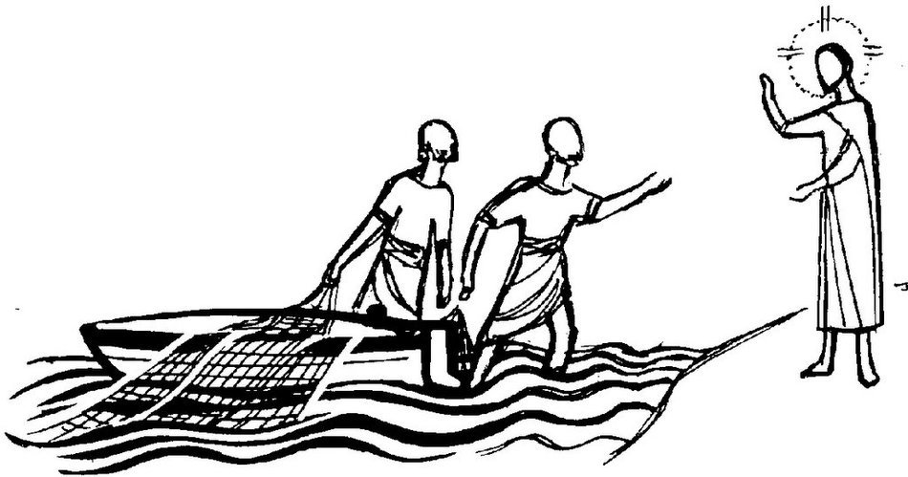
Will you come and follow me?
-ELW 798
Holy Trinity Evangelical
Lutheran Church

24655 87th Avenue
Bellerose, NY 11426
Phone: 718-347-0278
Web: holytrinitybellerose.org
E-mail: office@holytrintybellerose.org
Pastor’s E-mail: pastoranalyse@holytrinitybellerose.org

Rev. Analyse Triolo | Pastor
Olivia Lu | Organist
Jean Klarman | Musician
Rakesh Rajbali | Assisting Minister
Tatyana Rajbali | Reader
Barney Gallagher | Usher
Evelyn Kimmich | Communion Assistant & Usher
Aidan Hanratty | Video

Worship Music & Liturgy Licensing
CCLI: 1510407, OneLicense: 732293-A
Augsburg Fortress Liturgies: SAS0

