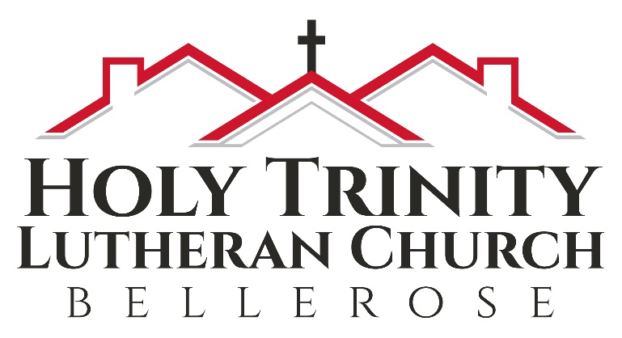

Ash Wednesday

Holy Communion
& Imposition of Ashes

February 22, 2023
8 pm

Facebook Live
www.facebook.com/HTLCBBellerose

We are blessed that you have joined us today.

Notes on worship:

BOLD type = people of God = You

Regular type = leader

Italic type = directions or explanations

Introduction to the Day

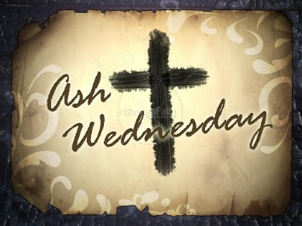
On Ash Wednesday we begin our forty-day journey toward Easter with a day of fasting and repentance. Marking our foreheads with dust, we acknowledge that we die and return to the earth. At the same time, the dust traces the life-giving cross indelibly marked on our foreheads at baptism. While we journey through Lent to return to God, we have already been reconciled to God through Christ. We humbly pray for God to make our hearts clean while we rejoice that “now is the day of salvation.” Returning to our baptismal call, we more intentionally bear the fruits of mercy and justice in the world.

WELCOME

We are delighted that you are here with us in person and online! If you have a church home at present but are prevented from joining with them because of the Coronavirus, we say
Welcome to you for the present. If you do not have a church home, please consider Holy Trinity to be yours! If Pastor Analyse or the Prayer Team can provide any care for you at presence please reach out in person or at pastoranalyse@holytrinitybellerose.org or the church office at office@holytrinitybellerose.org.

et the light from this candle say to all that
God’s hope is coming on earth as it already is in heaven…
Friends, be not afraid, God’s hope is at hand…
~Please stand as you are able for the confession and
forgiveness. I will read the text in the bulletin and I invite you to
echo it in your hearts.

GATHERING HYMN ELW 843 vs 1&3
Praise the One Who Breaks the Darkness

1 Praise the One who breaks the darkness
with a liberating light;
praise the One who frees the pris'ners,
turning blindness into sight.
Praise the One who preached the gospel,
healing ev'ry dread disease,
calming storms and feeding thousands
with the very bread of peace.

3 Praise the one true love incarnate:
Christ, who suffered in our place;
Jesus died and rose for many
that we may know God by grace.
Let us sing for joy and gladness,
seeing what our God has done.
Praise the one redeeming glory;
praise the One who makes us one.

GREETING

The grace of our lord Jesus Christ, the love of God, and the communion of the Holy Spirit be with you all.
And also with you.

PRAYER OF THE DAY

Almighty and ever-living God, you hate nothing you have made, and you forgive the sins of all who are penitent. Create in us new and honest hearts, so that, truly repenting of our sins, we may receive from you, the God of all mercy, full pardon and forgiveness through your Son, Jesus Christ, our Savior and Lord, who lives and reigns with you and the Holy Spirit, one God, now and forever.
Amen.

Hymn of Praise This is the Day W&P 141

This is the day, this is the day
that the Lord has made, that the Lord has made;
we will rejoice, we will rejoice
and be glad in it, and be glad in it.
This is the day that the Lord has made;
we will rejoice and be glad in it.
This is the day, this the day that the Lord has made.

First Reading Joel 2:1-2,12-17 NRSV
Because of the coming day of the Lord, the prophet Joel calls the people to a community lament. The repentant community declares that God is gracious and asks God to spare the people lest the nations doubt God’s power to save.

A reading from Joel, beginning at the 2nd chapter:
¹Blow the trumpet in Zion;
sound the alarm on my holy mountain!
Let all the inhabitants of the land tremble,
for the day of the Lord is coming, it is near
²a day of darkness and gloom, a day of clouds and thick darkness! Like blackness spread upon the mountains a great and powerful army comes; their like has never been from of old, nor will be again after them
in ages to come.
¹²Yet even now, says the Lord,
return to me with all your heart,
with fasting, with weeping, and with mourning;
¹³rend your hearts and not your clothing.
Return to the Lord, your God,
for he is gracious and merciful,
slow to anger, and abounding in steadfast love, and relents from punishing.
¹⁴Who knows whether he will not turn and relent, and leave a blessing behind him,
a grain offering and a drink offering
for the Lord, your God?
¹⁵Blow the trumpet in Zion;
sanctify a fast; call a solemn assembly;
¹⁶gather the people. Sanctify the congregation; assemble the aged;
gather the children, even infants at the breast. Let the bridegroom leave his room,
and the bride her canopy.
¹⁷Between the vestibule and the altar
let the priests, the ministers of the Lord, weep.
Let them say, “Spare your people, O Lord,
and do not make your heritage a mockery,
a byword among the nations.
Why should it be said among the peoples,
‘Where is their God?’ ”
The Word of the Lord.
Thanks be to God.

PSALM 51:1-17 NRSV

We will now read responsively from Psalm 51.
¹Have mercy on me, O God, according to your steadfast love; in your great compassion blot out my offenses.
²Wash me through and through from my wickedness, and cleanse me from my sin.
³For I know my offenses, and my sin is ever before me.
⁴Against you only have I sinned and done what is evil in your sight; so you are justified when you speak and right in your judgment.
⁵Indeed, I was born steeped in wickedness,
a sinner from my mother’s womb.
⁶Indeed, you delight in truth deep within me, and would have me know wisdom deep within.
⁷Remove my sins with hyssop, and I shall be clean; wash me, and I shall be purer than snow.
⁸Let me hear joy and gladness;
that the body you have broken may rejoice.
⁹Hide your face from my sins,
and blot out all my wickedness.
¹⁰Create in me a clean heart, O God,
and renew a right spirit within me.
¹¹Cast me not away from your presence,
and take not your Holy Spirit from me.
¹²Restore to me the joy of your salvation
and sustain me with your bountiful Spirit.
¹³Let me teach your ways to offenders,
and sinners shall be restored to you.
¹⁴Rescue me from bloodshed, O God of my salvation, and my tongue shall sing of your righteousness.
¹⁵O Lord, open my lips,
and my mouth shall proclaim your praise.
¹⁶For you take no delight in sacrifice, or I would give it.
You are not pleased with burnt offering.
¹⁷The sacrifice of God is a troubled spirit;
a troubled and broken heart, O God, you will not despise.

THE HOLY GOSPEL Matthew 6:1-6,16-21
NRSV
In the Sermon on the Mount, Jesus commends almsgiving, prayer, and fasting, but emphasizes that spiritual devotion must not be done for show.

The Holy Gospel according to St. Matthew,
the 6th chapter.
Glory to you, O Lord.
Jesus said to the disciples: ¹“Beware of practicing your piety before others in order to be seen by them; for then you have no reward from your Father in heaven.
²“So whenever you give alms, do not sound a trumpet before you, as the hypocrites do in the synagogues and in the streets, so that they may be praised by others. Truly I tell you, they have received their reward. ³But when you give alms, do not let your left hand know what your right hand is doing, ⁴so that your alms may be done in secret; and your Father who sees in secret will reward you.
⁵“And whenever you pray, do not be like the hypocrites; for they love to stand and pray in the synagogues and at the street corners, so that they may be seen by others. Truly I tell you, they have received their reward. ⁶But whenever you pray, go into your room and shut the door and pray to your Father who is in secret; and your Father who sees in secret will reward you.
¹⁶“And whenever you fast, do not look dismal, like the hypocrites, for they disfigure their faces so as to show others that they are fasting. Truly I tell you, they have received their reward. ¹⁷But when you fast, put oil on your head and wash your face, ¹⁸so that your fasting may be seen not by others but by your Father who is in secret; and your Father who sees in secret will reward you.
¹⁹“Do not store up for yourselves treasures on earth, where moth and rust consume and where thieves break in and steal; ²⁰but store up for yourselves treasures in heaven, where neither moth nor rust consumes and where thieves do not break in and steal. ²¹For where your treasure is, there your heart will be also.”
The Gospel of the Lord.
Praise to you, O Christ

BLESSING THE DUST
(Read responsively)

All those days you felt like dust, like dirt,
as if all you had to do was turn your face toward the wind
and be scattered to the four corners
or swept away by the smallest breath as insubstantial
did you not know what the Holy One can do with dust? This is the day we freely say we are scorched.
This is the hour we are marked by what has made it through the burning.
This is the moment we ask for the blessing that lives within the ancient ashes,
that makes its home inside the soil of this sacred earth.
So let us be marked not for sorrow.
And let us be marked not for shame.
Let us be marked not for false humility
or for thinking we are less than we are
but for claiming what God can do
within the dust, within the dirt,
within the stuff of which the world is made
and the stars that blaze in our bones
and the galaxies that spiral inside the smudge we bear.

(Jan Richardson from Circle of Grace: A Book of Blessings for the Seasons)

HYMN OF THE DAY ELW 793 vs 1&2
Be Thou My Vision

1 Be thou my vision, O Lord of my heart;
naught be all else to me, save that thou art:
thou my best thought by day and by night,
waking or sleeping, thy presence my light.
2 Be thou my wisdom, and thou my true word;
I ever with thee and thou with me, Lord.
Thou my soul’s shelter, thou my high tower,
raise thou me heav’nward, O Pow’r of my pow’r.

INVITATION TO LENTEN DISCIPLINE
Friends in Christ, today with the whole church we enter the time of remembering Jesus' passover from death to life, and our life in Christ is renewed.
We begin this holy season by acknowledging our need for repentance and for God's mercy. We are created to experience joy in communion with God, to love one another, and to live in harmony with creation. But our sinful rebellion separates us from, our neighbors, and creation, so that we do not enjoy the life our creator intended.
As disciples of Jesus, we are called to a discipline that contends against evil and resists whatever leads us away from love of God and neighbor. I invite you, therefore, to the discipline of Lent--self-examination and repentance, prayer and fasting, sacrificial giving and works of love--strengthened by the gifts of word and sacrament. Let us continue our journey through these forty days to the great Three Days of Jesus' death and resurrection.

CONFESSION and forgiveness

Blessed be the holy Trinity, ☩ one God,
who journeys with us these forty days,
and sustains us with the gift of grace.
Amen.
Let us acknowledge before God and one another
our need for repentance and God’s mercy.
Silence is kept for reflection.
Holy God,
we confess to you our faults and failings.
Too often we neglect and do not trust your holy word;
we take for ourselves instead of giving to others;
we spoil rather than steward your creation;
we cause hurt though you call us to heal;
we choose fear over compassion.
Forgive us, renew us, and lead us,
as we seek to follow in your way of life.
Amen.
Hear the good news:
God so loved the world that God gave the only Son,
so that all may receive life.
This promise is for you!
God embraces you with divine mercy,
☩ forgives you in Christ’s name,
and revives you in the Spirit’s power.
Amen.


IMPOSITION OF ASHES
The Imposition of Ashes is offered for all those who desire to receive this sign of mortality, repentance, and renewal. At this time families are invited to take their ashes and make the sign of the ☩ on one another’s foreheads, or on your own saying the prayer below:

Almighty God, you have created is out of the dust of the earth. May these ashes be a sign of our mortality and penitence, reminding us that only by the cross of our Lord Jesus Christ are we given eternal life; through Jesus Christ, our Savior & Lord. Amen.

Remember that you are dust, and to dust you shall return. Accomplish in us, O God, the work of your salvation,
That we may show forth your glory in the world.
By the cross and passion of your Son, our Savior,
Bring us with all your saints to the joy of his resurrection.
Almighty God have mercy on us all, forgive us our sins through our Lord Jesus Christ, strengthen us in all. Keep us in eternal life.
Amen

Prayers of the people

Sustained by God’s abundant mercy, let us pray for the church, the world, and all of creation.
A brief silence.
O Lord, our God, you gather your church and call us to return to you. Accompany us throughout our Lenten pilgrimage. Create in us clean hearts and renew all the baptized to declare your praise. Merciful God,
receive our prayer.
Renew your creation, O God. Bring rains to parched places and heal lands affected by a changing climate especially here in New York, that all inhabitants of the earth experience your abundance. Merciful God,
receive our prayer.
Renew the nations, O God. Give voice to those on the margins and resolve to world leaders who seek to protect those most vulnerable. Loosen the bonds of injustice and bring an end to all violence, oppression, and persecution. Merciful God, receive our prayer.
Renew your people, O God. Respond to those who cry out to you in secret or in seclusion. Equip us with compassion to care for those who experience homelessness, food insecurity, economic hardship, and illness especially, Laura Occhiogrosso, Bob Sarro, Tom Sanfedele, Brian Sherwood, Phil Hartman, Susan Martin, Rhonda Winters, Carol Lynch, Valerie Jones-Washington, Brian Sherwood, Jonathan Hussain, Heather Chittum, Bob Buckley, Heidi Neumark, Lynn Zernickow, Klohe Goetz, Francesca Girodano, and the family of Tina Burns.
Merciful God,
receive our prayer.
Renew this congregation, O God. Inspire our faith formation ministries and those who teach and lead. Invigorate us with lifelong curiosity and wonder as we grow as your disciples. Merciful God,
receive our prayer.
Renew our relationships, O God, with wonderful diversity of languages and cultures you created all people in your own image. Free our world from prejudice and fear, that we may see your face in the faces of siblings in Christ here, and around the world.
Merciful God,
receive our prayer.
Renew our health, O God. You showed Your power and caring by healing people of all ages and stations of life from physical, mental, and spiritual ailments. Be present now to people who need Your loving touch because of COVID-19, the flu, RSV and other illnesses this winter. May they feel Your power of healing through the care of doctors and nurses. Merciful God,
receive our prayer.
O Lord, our God, we give thanks for all your faithful ones of every time and place. Renew us by the example of their lives of prayer and service, and at the last, bring us with them into your everlasting presence. Merciful God,
receive our prayer.
We lift our prayers to you, O God, trusting in your steadfast love and your promise to renew your whole creation, through Jesus Christ our Savior.
Amen.

SHARING OF CHRIST’S PEACE
The peace of the Lord be with you always!
And also with you!
Let us share a sign of Christ’s peace with one another.

Offering

Musical Interlude

Offertory Hymn
Give Thanks

Give thanks with a grateful heart, give thanks to the Holy One, give thanks because he’s given Jesus Christ, his Son. Give thanks with a grateful heart, give thanks to the Holy One, give thanks because he’s given Jesus Christ, his Son.

And now let the weak say, “I am strong,” let the poor say, “I am rich,” because of what the Lord has done for us. And now let the weak say, “I am strong,” let the poor say, “I am rich,” because of what the Lord has done for us. Give thanks!

Offertory Prayer
God of good gifts,
receive these and all our offerings
as we present them in faithful service
for the sake of your gospel.
Prepare our hearts to receive you in this meal
as you pour out your very presence
through Christ Jesus, the wellspring of eternal life.
Amen.

GREAT THANKSGIVING

The Lord be with you.
And also with you.
Lift up your hearts.
We lift them to the Lord.
Let us give thanks to the Lord our God.
It is right to give our thanks and praise.
PREFACE
It is indeed right, our duty and our joy, that we should at all times and in all places give thanks and praise to you, almighty and merciful God, through our Savior Jesus Christ. You call your people to cleanse their hearts and prepare with joy for the paschal feast, that, renewed in the gift of baptism, we may come to the fullness of your grace. And so, with all the choirs of angels, with the church on earth and the hosts of heaven, we praise your name and join their unending hymn:

Holy, Holy, Holy
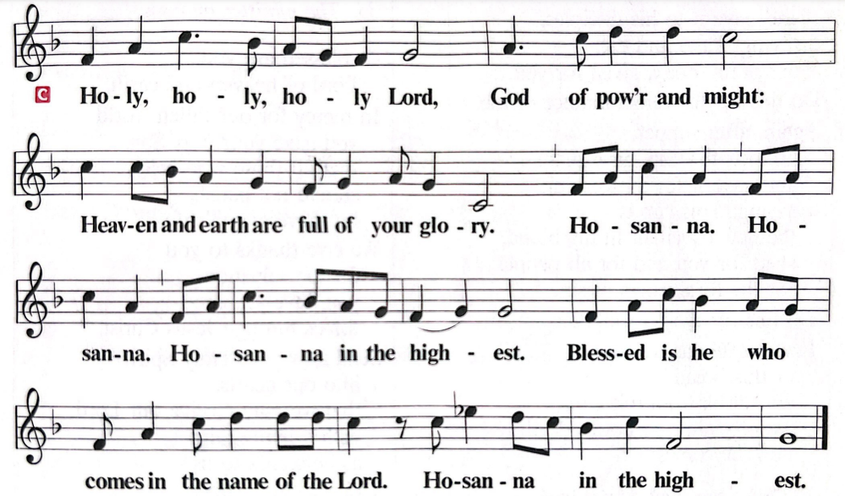

EUCHARISTIC PRAYER
O God triune, how majestic is your name in all the earth.
Over the eons your merciful might evolved our home, a fragile tree of life.
Here by your wisdom are both life and death, growth and decay,
the nest and the hunt, sunshine and storm.
Sustained by these wonders, we creatures of dust join in the ancient song:
The earth is full of your glory:
The earth is full of your glory.
O God triune, you took on our flesh in Jesus our healer.
In Christ you bring life from death;
we remember his cross, we laud his resurrection.
Broken like bread, he enlivens our body.
Outpoured like wine, he fills the earth with goodness.
Receiving this mystery, we mortals sing our song:
The earth is full of your glory:
The earth is full of your glory.
We praise you for the heart of Jesus,
so filled with your love for this earth.
On the night before he died, he took bread, and gave thanks, broke it, and gave it to his disciples, saying:
Take and eat; this is my body, given for you.
Do this for the remembrance of me.
Again, after supper, he took the cup, gave thanks,
and gave it for all to drink, saying:
This cup is the new covenant in my blood,
shed for you and for all people for the forgiveness of sin. Do this for the remembrance of me.
Gathered around this table, we your children unite in this song: The earth is full of your glory:
The earth is full of your glory.
O God triune, you create the worlds, you uphold the living, you embrace the dead.
Send forth your Spirit and renew the face of the earth.
Strengthen us for our journey with this meal, the body and blood of Christ.
Give us a future that trusts in you and cares for your earth.
Empowered by your promises, we rise from our deaths to praise you again: The earth is full of your glory:

The earth is full of your glory.
Amen, and amen.
Amen, and amen.
Copyright © 2017 Augsburg Fortress. All rights reserved.
Reproduced by permission.

LORD’S PRAYER
Lord, remember us in your kingdom and teach us to pray:

Our Father, who art in heaven, hallowed be thy name, thy kingdom come, thy will be done, on earth as it is in heaven. Give us this day our daily bread; and forgive us our trespasses, as we forgive those who trespass against us; and lead us not into temptation, but deliver us from evil. For thine is the kingdom, and the power, and the glory, forever and ever. Amen

COMMUNION
All are welcome to the Lord’s Table. When you come to the front please wear your mask while receiving the elements. We ask that you wait until you are back at your seat to partake. Please tell the ushers if you need the bread and wine brought to you. If you are not yet receiving communion, or do not wish to receive today, please come forward and cross your arms over your chest to receive a blessing. Follow the usher’s directions.
INVITATION TO COMMUNION

Here is food and drink for the journey.
Take and be filled.

TABLE BLESSING
May the body and blood of our Lord Jesus Christ, strengthen you and keep you in his grace. Amen.
POST COMMUNION PRAYER
Embodied God,
at your table, we have tasted the goodness of Jesus.
With the eyes of our hearts open to your promise,
empower us to hear the needs of our neighbors
and touch the world with your love.
Amen.
CLOSING LITANY
The End is God’s. The Beginning is God’s.
The Storm is God’s. The Peace is God’s.
The Depths are God’s. The Heights are God’s.
The Dark is God’s. The Light is God’s.
For all times, all things and all, all belong to God.
Travel with God to the end from the beginning.
Walk with the Lord of your salvation.
Continue with God during the storm as well as the peace.
Walk with the God of your deliverance.
Journey with God through the depths and the heights.
Walk with the Lord of your restoration.
Tarry with God in the dark and the light.
Walk with the Lord of your assurance;
For all times, all things and all, all belong to God. Amen.
“Copyright © 1999 Lisa Frenz. All Rights Reserved. Used with permission."

BLESSING
God, the giver of love,
☩ Christ, the resurrection and the life,
and the Holy Spirit of rebirth
bless you in this Lenten journey.
Amen.

SENDING HYMN ELW 326

Bless Now the Journey

Bless now, O God, the journey
that all your people make,
the path through noise and silence,
the way of give and take.
The trail is found in desert
and winds the mountain round,
then leads beside still waters,
the road where faith is found.

Bless sojourners and pilgrims
who share this winding way;
your hope burns through the terrors,
your love sustains the day.
We yearn for holy freedom
while often we are bound;
together we are seeking
the road where faith is found.

DISMISSAL
What is our Mission? Welcoming all to grow in faith; living Christ’s message of serving and loving neighbors near and far.
Go in peace. Jesus meets you on the way.
Thanks be to God.
Thank you for worshipping with us today. We are blessed by your presence.



HOLY WEEK DATES:

Palm Sunday ☩ April 2, 2023
Maundy Thursday ☩ April 6, 2023
Good Friday ☩ April 7, 2023
Resurrection of Our Lord ☩ April 9, 2023
Details to Follow
ASH WEDNESDAY

In Biblical times, ashes were a sign of sorrow, mourning, and repentance.
Why do we need to be sorrowful and repent? Because as the words of this popular children’s rhyme reminds us: we all fall down.

No matter how hard we try, we all fail and fall into sin. We don’t deserve the grace and mercy that God gives us; yet we receive it thanks to the pain and suffering that Jesus bore for us on the cross.
The cross where we see our Savior’s forgiving love put in action.

This is why on Ash Wednesday, we confess our sinful ways and receive the ashen cross on our foreheads; a visible sign of our repentance; a visible sign of Christ’s redeeming work for us on the cross. Thank you for joining us to receive the joyful Good News that our sins are forgiven.

Holy Trinity Evangelical
Lutheran Church
24655 87th Avenue
Bellerose, NY 11426
Phone: 718-347-0278

Web: holytrinitybellerose.org
E-mail: office@holytrintybellerose.org
Pastor’s E-mail: pastoranalyse@holytrinitybellerose.org

Rev. Analyse Triolo | Pastor
Olivia Lu | Organist
Jean Klarman | Musician
Denice Watkins | Assisting Minister
Tatyana Rajbali | Reader
Bill Robinson | Usher
Carol Robinson | Communion Assistant & Usher
Kristian Persad | Video

Worship Music & Liturgy Licensing
CCLI: 1510407
OneLicense: 732293-A
Augsburg Fortress Liturgies: SAS0068

