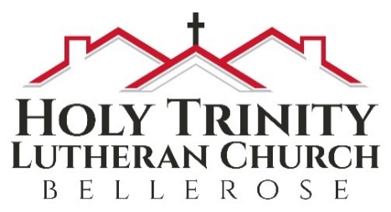
Holy Trinity Evangelical Lutheran Church

March 19, 2023
10:00 am

fourth Sunday in lent

We are blessed that you have joined us to celebrate the birth of Our Savior.

Notes on worship:
BOLD type = people of God = You
Regular type = leader
Italic type = directions or explanations

PRELUDE

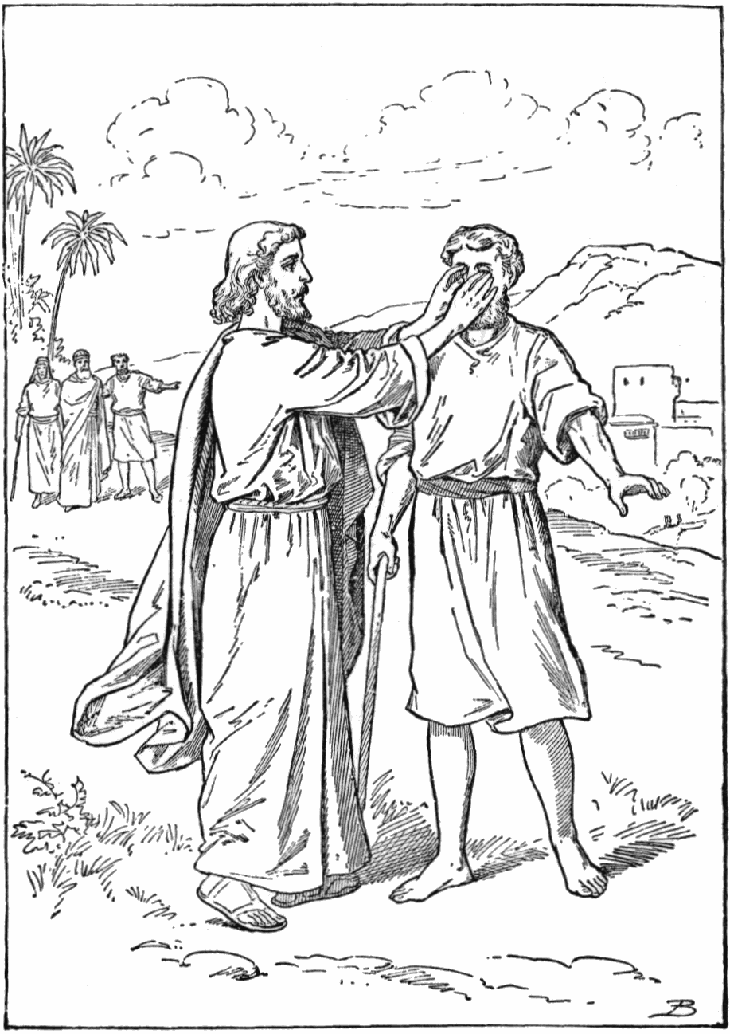
Introduction to the Day
Baptism is sometimes called enlightenment. The gospel for this Sunday is the story of the man born blind healed by Christ. “I was blind, now I see,” declares the man. In baptism God opens our eyes to see the truth of who we are: God’s beloved children. As David was anointed king of Israel, in baptism God anoints our head with oil, and calls us to bear witness to the light of Christ in our daily lives.

WELCOME
We are delighted that you are here with us in person and online! If you have a church home at present but are prevented from joining with them because of the Coronavirus, we say
Welcome to you for the present. If you do not have a church home, please consider Holy Trinity to be yours! If Pastor Analyse or the Prayer Team can provide any care for you at presence please reach out in person or at pastoranalyse@holytrinitybellerose.org or the church office at office@holytrinitybellerose.org.

~Please stand as you are able~

Confession and Forgiveness
Blessed be the holy Trinity, ☩ one God,
who journeys with us these forty days,
and sustains us with the gift of grace.
Amen.
Let us acknowledge before God and one another
our need for repentance and God’s mercy.
Silence is kept for reflection.
Holy God,
we confess to you our faults and failings.
Too often we neglect and do not trust your holy word;
we take for ourselves instead of giving to others;
we spoil rather than steward your creation;
we cause hurt though you call us to heal;
we choose fear over compassion.
Forgive us, renew us, and lead us,
as we seek to follow in your way of life.
Amen.
Hear the good news:
God so loved the world that God gave the only Son,
so that all may receive life.
This promise is for you!
God embraces you with divine mercy,
☩ forgives you in Christ’s name,
and revives you in the Spirit’s power.
Amen.

GATHERING HYMN ELW 673 vs 1,2,4
God, Whose Almighty Word

1 God, whose almighty word
chaos and darkness heard
and took their flight:
hear us, we humbly pray,
and where the gospel day
sheds not its glorious ray,
let there be light!

2 Christ, who once came to bring,
on your redeeming wing,
healing and sight,
health to the troubled mind,
sight where illusions blind:
oh, now to humankind
let there be light!

4 Holy and blessed three,
glorious Trinity,
wisdom, love, might!
Boundless as ocean’s tide,
rolling in fullest pride,
through the earth, far and wide,
let there be light!

GREETING
The grace of our Lord Jesus Christ, the love of God, and the communion of the Holy Spirit be with you all.
And also with you.

Hymn of Praise W&P 141
This is the Day
This is the day, this is the day that the Lord has made, that the Lord has made;
we will rejoice, we will rejoice
and be glad in it, and be glad in it.
This is the day that the Lord has made;
we will rejoice and be glad in it.
This is the day, this the day that the Lord has made. Repeat

PRAYER OF THE DAY
Bend your ear to our prayers, Lord Christ, and come among us. By your gracious life and death for us, bring light into the darkness of our hearts, and anoint us with your Spirit, for you live and reign with the Father and the Holy Spirit, one God, now and forever. Amen.

~Please be seated.~

First reading 1 Samuel 16:1-13
Samuel anointed David even though he was the eighth-oldest son of Jesse and did not match his brothers in height or other physical characteristics. With the anointing came endowment with the Spirit of the Lord, designating David as the Lord’s chosen successor to Saul.
The first reading is from first Samuel beginning at the sixteenth chapter.
¹The Lord said to Samuel, “How long will you grieve over Saul? I have rejected him from being king over Israel. Fill your horn with oil and set out; I will send you to Jesse the Bethlehemite, for I have provided for myself a king among his sons.” ²Samuel said, “How can I go? If Saul hears of it, he will kill me.” And the Lord said, “Take a heifer with you, and say, ‘I have come to sacrifice to the Lord.’ ³Invite Jesse to the sacrifice, and I will show you what you shall do; and you shall anoint for me the one whom I name to you.” ⁴Samuel did what the Lord commanded, and came to Bethlehem. The elders of the city came to meet him trembling, and said, “Do you come peaceably?” ⁵He said, “Peaceably; I have come to sacrifice to the Lord; sanctify yourselves and come with me to the sacrifice.” And he sanctified Jesse and his sons and invited them to the sacrifice.
⁶When they came, he looked on Eliab and thought, “Surely the Lord’s anointed is now before the Lord.” ⁷But the Lord said to Samuel, “Do not look on his appearance or on the height of his stature, because I have rejected him; for the Lord does not see as mortals see; they look on the outward appearance, but the Lord looks on the heart.” ⁸Then Jesse called Abinadab, and made him pass before Samuel. He said, “Neither has the Lord chosen this one.” ⁹Then Jesse made Shammah pass by. And he said, “Neither has the Lord chosen this one.” ¹⁰Jesse made seven of his sons pass before Samuel, and Samuel said to Jesse, “The Lord has not chosen any of these.” ¹¹Samuel said to Jesse, “Are all your sons here?” And he said, “There remains yet the youngest, but he is keeping the sheep.” And Samuel said to Jesse, “Send and bring him; for we will not sit down until he comes here.” ¹²He sent and brought him in. Now he was ruddy, and had beautiful eyes, and was handsome. The Lord said, “Rise and anoint him; for this is the one.” ¹³Then Samuel took the horn of oil, and anointed him in the presence of his brothers; and the spirit of the Lord came mightily upon David from that day forward. Samuel then set out and went to Ramah.

Word of God, word of life.
Thanks be to God.

Psalm 23
We will now read responsively Psalm 23.
¹The Lord is my shepherd;
I shall not be in want.
²The Lord makes me lie down in green pastures
and leads me beside still waters.
³You restore my soul, O Lord,
and guide me along right pathways for your name’s sake.
⁴Though I walk through the valley of the shadow of death, I shall fear no evil;
for you are with me; your rod and your staff, they comfort me.
⁵You prepare a table before me in the presence of my enemies;
you anoint my head with oil, and my cup is running over.
⁶Surely goodness and mercy shall follow me all the days of my life,
and I will dwell in the house of the Lord forever.

SECOND READING Ephesians 5:8-14
Because we now live in the divine light which is Jesus Christ, we conduct our lives in ways that reflect the light of Christ, so that our activity is truly pleasing to God.
The second reading is from Ephesians beginning at the fifth chapter.
⁸Once you were darkness, but now in the Lord you are light. Live as children of light—⁹for the fruit of the light is found in all that is good and right and true. ¹⁰Try to find out what is pleasing to the Lord. ¹¹Take no part in the unfruitful works of darkness, but instead expose them. ¹²For it is shameful even to mention what such people do secretly; ¹³but everything exposed by the light becomes visible, ¹⁴for everything that becomes visible is light. Therefore it says,
“Sleeper, awake!
Rise from the dead,
and Christ will shine on you.”
HOLY GOSPEL John 9:1-41
Jesus heals a man born blind, provoking a hostile reaction that he regards as spiritual blindness to the things of God.

The Holy Gospel according to John beginning at the ninth chapter.
Glory to you, O Lord!
¹As Jesus walked along, he saw a man blind from birth. ²His disciples asked him, “Rabbi, who sinned, this man or his parents, that he was born blind?” ³Jesus answered, “Neither this man nor his parents sinned; he was born blind so that God’s works might be revealed in him. ⁴We must work the works of him who sent me while it is day; night is coming when no one can work. ⁵As long as I am in the world, I am the light of the world.” ⁶When he had said this, he spat on the ground and made mud with the saliva and spread the mud on the man’s eyes, ⁷saying to him, “Go, wash in the pool of Siloam” (which means Sent). Then he went and washed and came back able to see. ⁸The neighbors and those who had seen him before as a beggar began to ask, “Is this not the man who used to sit and beg?” ⁹Some were saying, “It is he.” Others were saying, “No, but it is someone like him.” He kept saying, “I am the man.” ¹⁰But they kept asking him, “Then how were your eyes opened?” ¹¹He answered, “The man called Jesus made mud, spread it on my eyes, and said to me, ‘Go to Siloam and wash.’ Then I went and washed and received my sight.” ¹²They said to him, “Where is he?” He said, “I do not know.”
¹³They brought to the Pharisees the man who had formerly been blind. ¹⁴Now it was a sabbath day when Jesus made the mud and opened his eyes. ¹⁵Then the Pharisees also began to ask him how he had received his sight. He said to them, “He put mud on my eyes. Then I washed, and now I see.” ¹⁶Some of the Pharisees said, “This man is not from God, for he does not observe the sabbath.” But others said, “How can a man who is a sinner perform such signs?” And they were divided. ¹⁷So they said again to the blind man, “What do you say about him? It was your eyes he opened.” He said, “He is a prophet.”
¹⁸The Jews did not believe that he had been blind and had received his sight until they called the parents of the man who had received his sight ¹⁹and asked them, “Is this your son, who you say was born blind? How then does he now see?” ²⁰His parents answered, “We know that this is our son, and that he was born blind; ²¹but we do not know how it is that now he sees, nor do we know who opened his eyes. Ask him; he is of age. He will speak for himself.” ²²His parents said this because they were afraid of the Jews; for the Jews had already agreed that anyone who confessed Jesus to be the Messiah would be put out of the synagogue. ²³Therefore his parents said, “He is of age; ask him.”
²⁴So for the second time they called the man who had been blind, and they said to him, “Give glory to God! We know that this man is a sinner.” ²⁵He answered, “I do not know whether he is a sinner. One thing I do know, that though I was blind, now I see.” ²⁶They said to him, “What did he do to you? How did he open your eyes?” ²⁷He answered them, “I have told you already, and you would not listen. Why do you want to hear it again? Do you also want to become his disciples?” ²⁸Then they reviled him, saying, “You are his disciple, but we are disciples of Moses. ²⁹We know that God has spoken to Moses, but as for this man, we do not know where he comes from.” ³⁰The man answered, “Here is an astonishing thing! You do not know where he comes from, and yet he opened my eyes. ³¹We know that God does not listen to sinners, but he does listen to one who worships him and obeys his will. ³²Never since the world began has it been heard that anyone opened the eyes of a person born blind. ³³If this man were not from God, he could do nothing.” ³⁴They answered him, “You were born entirely in sins, and are you trying to teach us?” And they drove him out.
³⁵Jesus heard that they had driven him out, and when he found him, he said, “Do you believe in the Son of Man?” ³⁶He answered, “And who is he, sir? Tell me, so that I may believe in him.” ³⁷Jesus said to him, “You have seen him, and the one speaking with you is he.” ³⁸He said, “Lord, I believe.” And he worshiped him. ³⁹Jesus said, “I came into this world for judgment so that those who do not see may see, and those who do see may become blind.” ⁴⁰Some of the Pharisees near him heard this and said to him, “Surely we are not blind, are we?” ⁴¹Jesus said to them, “If you were blind, you would not have sin. But now that you say, ‘We see,’ your sin remains.”
The Gospel of the Lord.
Praise to you, O Christ.

~Please be seated.~

CHILDREN’S MESSAGE

SERMON

~Please stand as you are able.~

HYMN OF THE DAY ELW 520 vs 1,2,?
Dearest Jesus, At Your Word

1 Dearest Jesus, at your word
we have come again to hear you;
let our thoughts and hearts be stirred
and in glowing faith be near you
as the promises here given
draw us wholly up to heaven.

2 All our knowledge, sense, and sight
lie in deepest darkness shrouded
till your Spirit breaks the night,
filling us with light unclouded.
All good thoughts and all good living
come but by your gracious giving.

NICENE Creed
Let us confess our faith saying the words of the Nicene Creed
We believe in one God, the Father, the Almighty, maker of heaven and earth, of all that is, seen and unseen.
We believe in one Lord, Jesus Christ, the only Son of God, eternally begotten of the Father, God from God, Light from Light, true God from true God, begotten, not made, of one Being with the Father; through him all things were made.
For us and for our salvation he came down from heaven, was incarnate of the Holy Spirit and the virgin Mary and became truly human. For our sake he was crucified under Pontius Pilate; he suffered death and was buried. On the third day he rose again in accordance with the scriptures; he ascended into heaven and is seated at the right hand of the Father. He will come again in glory to judge the living and the dead, and his kingdom will have no end.
We believe in the Holy Spirit, the Lord, the giver of life, who proceeds from the Father and the Son,* who with the Father and the Son is worshiped and glorified, who has spoken through the prophets.
We believe in one holy catholic and apostolic church. We acknowledge one baptism for the forgiveness of sins.
We look for the resurrection of the dead, and the life of the world to come. Amen.

THE PRAYERS OF THE PEOPLE

Sustained by God’s abundant mercy, let us pray for the church, the world, and all of creation.
A brief silence.
Eternal God, you seal us by the Holy Spirit and mark us with the cross of Christ forever in baptism. Inspire us by your love as together we strive for justice and peace in all the earth. Merciful God,
receive our prayer.
Creating God, by your word you have made all things, and you hate nothing you have made. Teach us to perceive the beauty of the breadth of your creation, from the grandest mountain range to the smallest springtime bud. Merciful God,
receive our prayer.
Powerful God, you anoint kings and establish rulers. Guide the work of heads of state and elected officials. Encourage them to lead with justice and to remove barriers that impede the well-being of all. Merciful God,
receive our prayer.
Shepherding God, you lead us beside still waters and restore our souls. Keep watch over those who weep; tend all who are sick and comfort those who grieve especially Laura Occhiogrosso, Bob Sarro, Tom Sanfedele, Brian Sherwood, Heather Chittum, Heidi Neumark, Lynn Zernickow, Klohe Goetz, Francesca Giordano, Mary Ann Gallagher, Mike, and Jackie Budds. Merciful God,
receive our prayer.
God our host, you fill us at your table with more than we could ever ask. Feed us with hunger for justice. Equip the feeding ministries of this congregation and community especially The Midnight Run and Food Pantry at All Saint’s Lutheran Church. Nourish us so we can nourish our neighbors. Merciful God,
receive our prayer.
Healing God, you call us to care for ourselves and one another. Be with all who are struggling with extended periods of illnesses this winter. May they feel Your power of healing through the care of doctors and nurses. Merciful God,
receive our prayer.
Welcoming God, you call us your Beloved Community. End racism and oppression in our world. Deliver all who are unjustly imprisoned or persecuted. Reconcile nations and peoples in conflict. Help us pray for our enemies. Merciful God,
receive our prayer.
God of history, with thanksgiving we remember our ancestors in faith who cared for your people. We praise you for the ways they formed the faith of others and continue to inspire us. Merciful God,
receive our prayer.
We lift our prayers to you, O God, trusting in your steadfast love and your promise to renew your whole creation; through Jesus Christ our Savior.
Amen.

SHARING OF CHRIST’S PEACE
The peace of the Lord be with you always.
And also with you.
Let us share a sign of Christ’s peace with one another.

OFFERING MESSAGE
Please be seated as we bring our offering to the Lord.

Musical Interlude

~Please stand as you are able.~

OFFERTORY HYMN W&P 41 vs 1,2
Just As I Am, Without One Plea

1 Just as I am, without one plea,
but that thy blood was shed for me,
and that thou bidd’st me come to thee,
O Lamb of God, I come, I come.

2 Just as I am, though tossed about
with many a conflict, many a doubt,
fightings and fears within, without,
O Lamb of God, I come, I come.

OFFERTORY PRAYER

God of good gifts,
receive these and all our offerings
as we present them in faithful service
for the sake of your gospel.
Prepare our hearts to receive you in this meal
as you pour out your very presence
through Christ Jesus, the wellspring of eternal life.
Amen.

GREAT THANKSGIVING
The Lord be with you.
And also with you.
Lift up your hearts.
We lift them to the Lord.
Let us give thanks to the Lord our God.
It is right to give our thanks and praise.

PREFACE
It is indeed right our duty and our joy that we should at all times and in all places offer thanks and praise to you, almighty and merciful God, through our Savior Jesus Christ. You call your people to cleanse their hearts and prepare with joy for the paschal feast, that renewed in the gift of baptism, we may come to the fullness of your grace. And so, with all the choirs of angels, with the church on earth and the hosts of heaven, we praise your name and join their unending hymn:

HOLY, HOLY, HOLY (Sung)

Holy, holy, holy Lord, God of power and might. Heaven and earth are full of your glory. Hosanna in the highest. Blessed is he who comes in the name of the Lord. Hosanna in the highest.

EUCHARISTIC PRAYER
In the night in which he was betrayed, our Lord Jesus took bread, gave thanks broke it, and gave it to his disciples, saying:
Take and eat; this is my body, given for you. Do this for the remembrance of me.
Again, after supper, he took the cup, gave thanks, and gave it for all to drink, saying: This cup is the new covenant in my blood, shed for you and for all people for the forgiveness of sin. Do this for the remembrance of me.
Remembering, therefore, his birth and life among us, his death and resurrection, we await his coming again when all things will be restored in him.
By your Spirit bless us and this bread and cup, that, held and nourished by you, we may live as your children, shining with the light of your Son.
Through him all glory and honor is yours, Almighty Father, with the Holy Spirit, in your holy Church, both now and forever. Amen.

THE LORD’S PRAYER
Lord, remember us in your kingdom and teach us to pray:
Our Father, who art in heaven, hallowed be thy name, thy kingdom come, thy will be done, on earth as it is in heaven.
Give us this day our daily bread; and forgive us our trespasses,
as we forgive those who trespass against us; and lead us not into temptation, but deliver us from evil.
For thine is the kingdom, and the power, and the glory, forever and ever. Amen

~Please be seated~

COMMUNION
All are welcome to the Lord’s Table. When you come to the front, wearing your mask is optional. Please tell the ushers if you need the bread and wine brought to you. If you are not yet receiving communion, or do not wish to receive today, please come forward and cross your arms over your chest to receive a blessing. Follow the usher’s directions.

Invitation to Communion
Come and receive Jesus, our strength in the
wilderness.

~Please stand as you are able~

TABLE BLESSING & COMMUNION PRAYER
The body and blood of our Lord Jesus Christ strengthen you and keep you in his grace. Amen.
Let us pray.
Embodied God, at your table, we have tasted the goodness of Jesus. With our hearts open to your promise, empower us to respond to the needs of our neighbors and to fill the world with your love.
Amen.
~Please be seated.~

ANNOUNCEMENTS

~Please stand as you are able.~

Blessing
God, the giver of love,
☩ Christ, the resurrection and the life,
and the Holy Spirit of rebirth
bless you in this Lenten journey.
Amen.

SENDING HYMN ELW 332 vs 1,3
I Heard The Voice Of Jesus Say

1 I heard the voice of Jesus say,
"Come unto me and rest;
lay down, O weary one, lay down
your head upon my breast."
I came to Jesus as I was,
so weary, worn, and sad;
I found in him a resting-place,
and he has made me glad.

3 I heard the voice of Jesus say,
"I am this dark world's light;
look unto me, your morn shall rise,
and all your day be bright."
I looked to Jesus, and I found
in him my star, my sun;
and in that light of life I'll walk
till trav'ling days are done.

DISMISSAL
What is our mission?
Welcoming all to grow in faith, living Christ’s message of serving and loving neighbors near and far.
Go in peace. Serve in love.
Thanks be to God!

Thank you for worshipping
with us today.

Announcements &
Coming Events

MEMORIAL
a memorial was given in loving memory of Buddy Poje by the Robinson Family.
In Person Services every Sunday Live and via Facebook Live @ 10:00 am. You don’t have to belong to Facebook to watch. Video will also be available on our interactive bulletin at: holytrinitybellerose.wordpress.com.
LENTEN BIBLE STUDY
Our Lenten Bible Study on the Gospel of John continues on Mondays at 10am and 7pm. Books are $15. Note: There will be no bible study on 3/27 or 4/10.
COUNCIL MEETING
Next meeting, Thursday, April 11 @

7:30 pm.
SHAMROCKIN’ & a-REUBEN DINNER
Tonight, March 19 at 6 pm.
Cost-Adults $15, Families $40. Signup sheet in the narthex.
WORSHIP & MUSIC
Next meeting TBA.
YOUTH GROUP
The youth meet twice a month on the first and third Saturday’s from beginning at 6:30 pm. Contact Diane Gilroy for more information.
ALTAR GUILD
Looking for volunteers to help Denice & Pastor Analyse with Altar Guild responsibilities.
Thrivent members
Remember to direct you Thrivent Choice Dollars to Holy Trinity. Talk to Ken Henyan if you have questions. Deadline 3/31.
Videographer volunteers needed
Learn a new skill. The camera is really user friendly. See Pastor for additional information.
YOGA PRACTICE
Yoga, Thursdays, at 7 pm in the Friendship Hall. One hour for only $10.
Contact Carol Robinson, 917-208-7340, for additional information.
BIRTHDAY CAKE SIGNUP SHEET FOR 2023
Please see signup sheet in the narthex.

March Birthdays & Anniversaries
1 Ray Holm
7 Ruth Loomis & Michael Greene
9 Patrick Clark
10 Katie Holm Charach
16 Carole Zahner
17 Marilyn Weickert
24 Rich & Helen Kunz
27 Joyce Holm
27 Christian Berg
28 Charlotte Williams
28 Leonard Scala
28 Jeff Slatkin
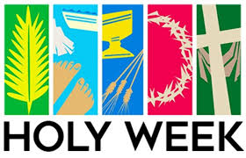

HOLY WEEK SCHEDULE
Palm Sunday ☩ April 2, 2023
Service at 10am
Palm Sunday Breakfast after Worship
Maundy Thursday ☩ April 6, 2023
Potluck & Service at 6pm
Good Friday ☩ April 7, 2023
Tenebrae Service at 8pm
Easter Sunday ☩ April 9, 2023
Service at 10am
Holy Trinity Evangelical
Lutheran Church
24655 87th Avenue
Bellerose, NY 11426
Phone: 718-347-0278
Web: holytrinitybellerose.org
E-mail: office@holytrintybellerose.org
Pastor’s E-mail: pastoranalyse@holytrinitybellerose.org

Analyse Triolo | Pastor
Olivia Lu | Organist
Jean Klarman | Musician
Linda Lago | Asst. Minister
Joe Innella | Reader
Carol Robinson | Communion Asst.  & Usher
Bill Robinson  Patty Innella | Usher  Video

Worship Music & Liturgy Licensing
CCLI: 1510407, OneLicense: 732293-A
Augsburg Fortress Liturgies: SAS00684

